

University Of Central Punjab

**Faculty of Information Technology  
Final Term Exam-Spring 2018**

**dkng**

**Course Title: Web Application Development**

|  |  |
| --- | --- |
| Course Instructor : Ali Makhkdoom, Muhammad Rehan Abbas | Semester: Spring 2018 |
| Duration : 3 Hours | Marks: |

Name: Registration Number

**INSTRUCTIONS**

1. Paper is open book/open notes.
2. Write your name and registration number on the Question Paper in the spaces provided.
3. Write with blue/black permanent ink pen.
4. Try to finish your exam within prescribed time.
5. Solve the paper on this paper no extra sheet is to be provided.

|  |  |  |  |  |  |
| --- | --- | --- | --- | --- | --- |
| **Q1** | **Q2** | **Q3** | **Q4** | **Q5** | **Total** |
| **10** | **10** | **20** | **20** | **20** | **80** |
|  |  |  |  |  |  |

You are required to create an online “Patient Management System” where you can add and delete the patients’ information. The database file for the task is provided in the FOIT LMS. DO NOT create any database table manually.

## Steps to import Database file.

1. Create a database with name pms.
2. Select the pms database and click on the import tab.
3. Browse the provided database file “pms.sql” and click “Go” button.

## signin.php page

1. Create the signin.php as the following screenshot.
2. If account is not already created, there is a link of Sign Up that takes you to signup.php page.
3. Clicking the sign in button will validate the username and password from the database table “users” provided in the sql file.
4. On successful validation, the user named must be saved in session variable and be shown on every page as Welcome [User Name]. Also use cookies to store the values of username and password, so that in the next login, you will not need to enter the credentials.

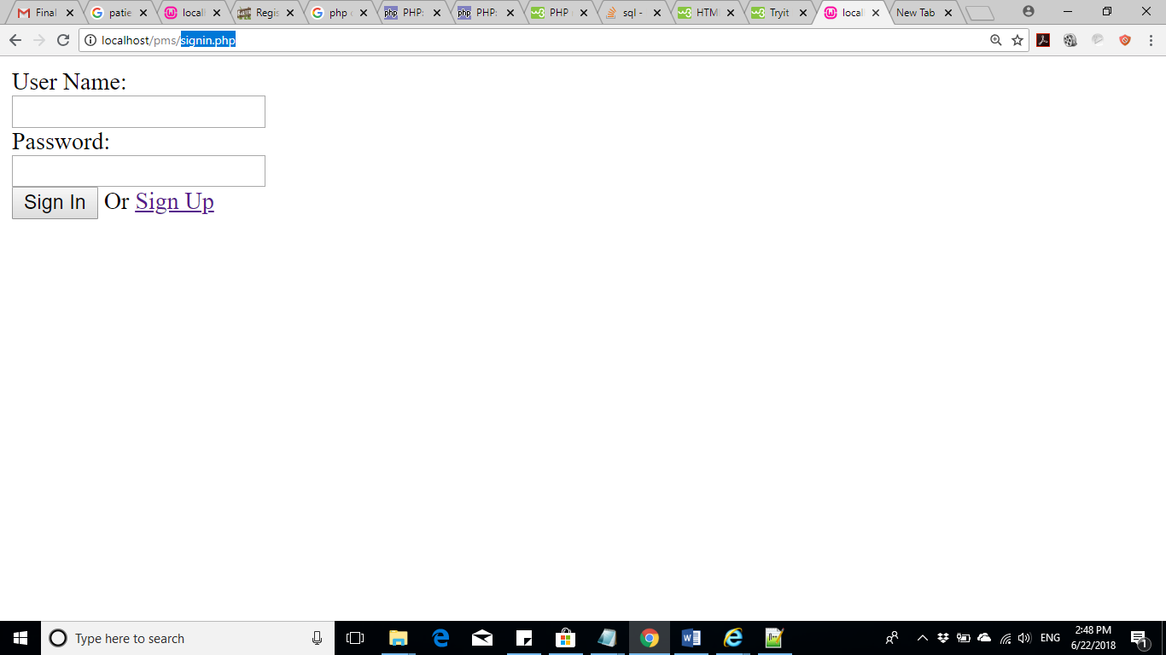

## signup.php page

1. The signup.php page is similar to signin.php page. It will create the user account by inserting username and password into users table and after successful signup, will take back to signin.php page.

## patients.php page

1. On start of this page, there must a be a check that the user is signed in. you can use session variables for the purpose.
2. If the user is not signed in, redirect to the signin.php page.
3. If the session variable does have the sign in information, display the user name as “Welcome [user name] and also,, show a link to “Sign Out” to sign out.
4. Create a web form containing cnic, name, disease info, entry date and time and discharge data and time.
5. Clicking the “Add Record” button will add the record from the web form into the database and display in the html tabl
6. The html table contains Delete link in the last column which would delete the respective record from database as well html table WITHOUT FLICKERING OR RELOADING OF THE PAGE.
7. NOTE, THE DELETE OPERETION MUST BE EXECUTED USING THE ASYNC CALL OF AJAX.

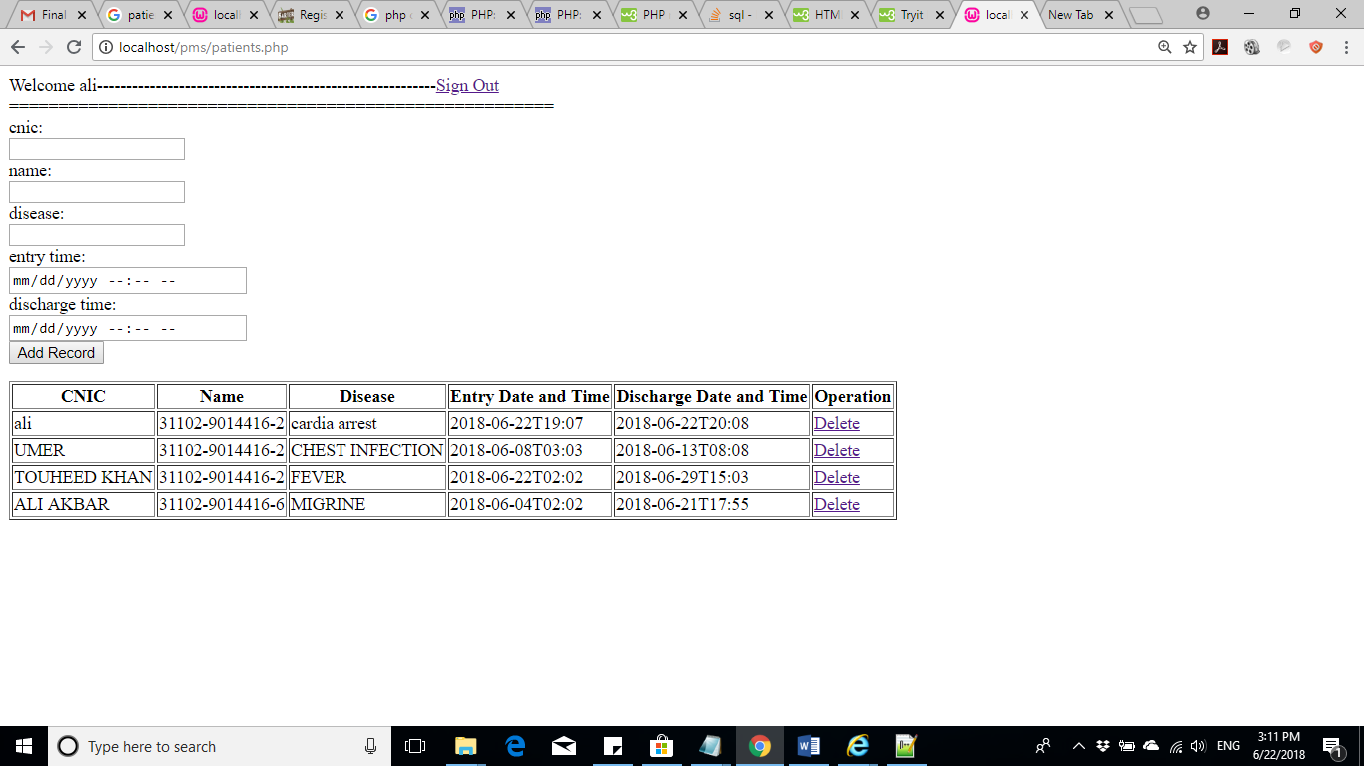

## signout.php page

1. Clicking the Sign Out link will take to the page signput.php where you would unset and destroy the session landing back at signin.php page.

## Marking Scheme

1. The Sign in part – 10
2. The Sign up part - 10
3. The session and cookies – 20
4. Patient Record Entry – 20
5. Patient Record Deletion using AJAX - 20

Hint: you can set the type= datetime-local” for entry time and discharge time.

<input type="datetime-local" >